Technical Architecture:

Project Design Phase-II Technology Stack (Architecture & Stack)

|  |  |
| --- | --- |
| Team member | Keerthini R |
| Team member | Keshavarthini A |
| Team member | Mohana M |
| Team Lead | Preethi T |

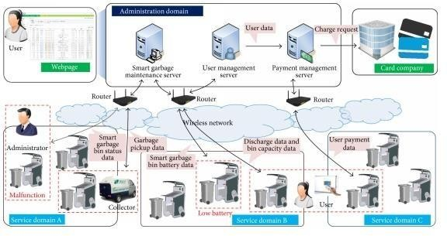

Table-1: Components & Technologies:

|  |  |  |  |
| --- | --- | --- | --- |
| **S.No** | **Component** | **Description** | **Technology** |
| 1. | User Interface | Mobile Application | HTML, CSS, JavaScript. |
| 2. | Application Logic | Logic for a process in the application | Java |
| 3. | Database | Data Type, Configurations etc. | MySQL |
| 4. | Cloud Database | Database Service on Cloud | IBM Cloud |
| 5. | File Storage | File storage requirements | Local Filesystem and IBM cloud |
| 6. | Infrastructure (Server / Cloud) | Application Deployment on Cloud | Local and Cloud Foundry |
| Local Server Configuration |

Table-2: Application Characteristics:

|  |  |  |  |
| --- | --- | --- | --- |
| **S.No** | **Characteristics** | **Description** | **Technology** |
| 1. | Open-Source Frameworks | GitHub | Internet hosting service |
| 2. | Security Implementations | Application security: Veracode | Network automation |
| Firewall: cisco |
| 3. | Scalable Architecture | It provides the room for expansion more database | Cloud storage |
| of smart bins added additionally can be updated. |
| 4. | Availability | As the system control is connected to web server it | Server |
| is available 24*7 and can be accessed whenever |
| needed. |
| 5. | Performance | Performance is high it uses 5mb caches | Wireless Sensor Network |